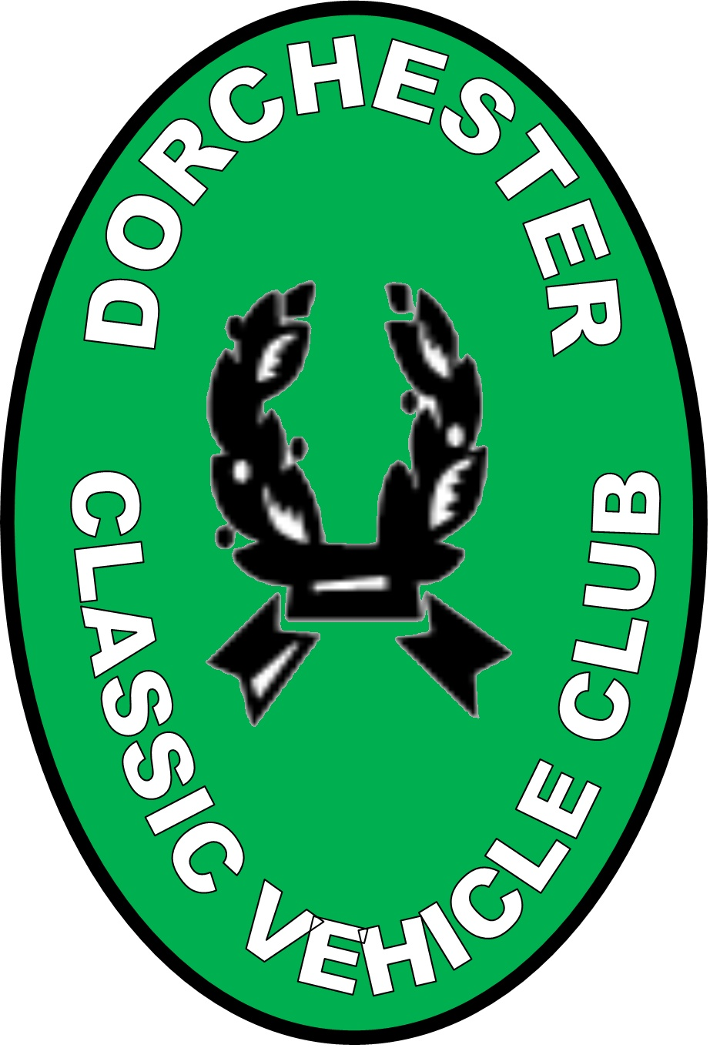
DORCHESTER CLASSIC VEHICLE CLUB
For owners of tax exempt Historic vehicles
(As descried by GOV.UK)
The small club with a big heart

Membership form
Date: ………..

Title: ………………….

Full Name: ………………………………............................

Full Address: ……………………………….........................

……………………………….........................

……………………………….........................

………………………………..........................

Home Phone Number: ……………………………...............

E- Mail Address: ………………………………......................

Full Membership is only £10.00 a year.

For this you receive a copy of the DCVC Journal emailed to you every month, monthly meetings,
Club Runs, Club Visits and club social events.

To comply with the General Data Protection Regulations 2018, all new members must sign the bottom of this membership form, giving permission for DCVC to hold the above personal information for administrative use only, and is not shared with any other persons or organizations.

Please sign here: ……………………………………………

Please make cheque’s payable to Dorchester Classic Vehicle Club
And return to the Membership Secretary
Mrs Yvonne Eley 60 Garfield Avenue Dorchester DT1 2EZ

